**STEP BY STEP PROCEDURE CAN TRACKS WITH CANANALYZER3MINI**

**By installing the new IXXAT drivers, the CanAnalyzer3Mini is automatically installed to make the can traces.**

**CanAnalyzer3 mini description and settings and step-by-step procedure:**

**1.Select the "bus setting" and set:**

• The can-bus speed like that of the inverter (bitrate a125 or 250 or 500Kb ... etc…)

• The type of protocol (suggested select “Both”).

• The display or not of the error-frames (suggested “Detect error-frame).

• If we want the active or passive cananalyzer (suggested “TX passive”).

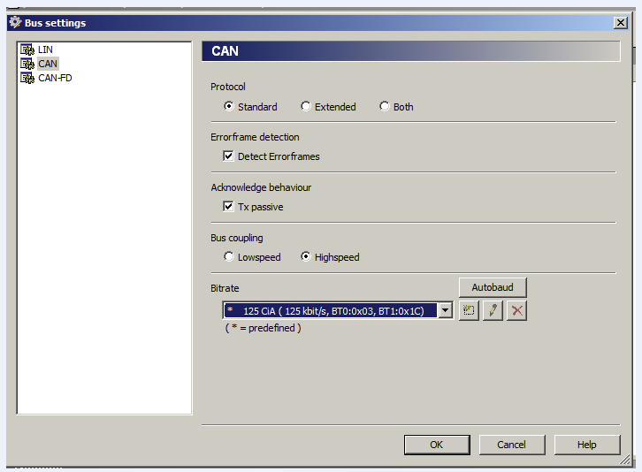

**2.Connect by clicking on the green flag (circled in red below) to connect and begin can communication with the inverter.**



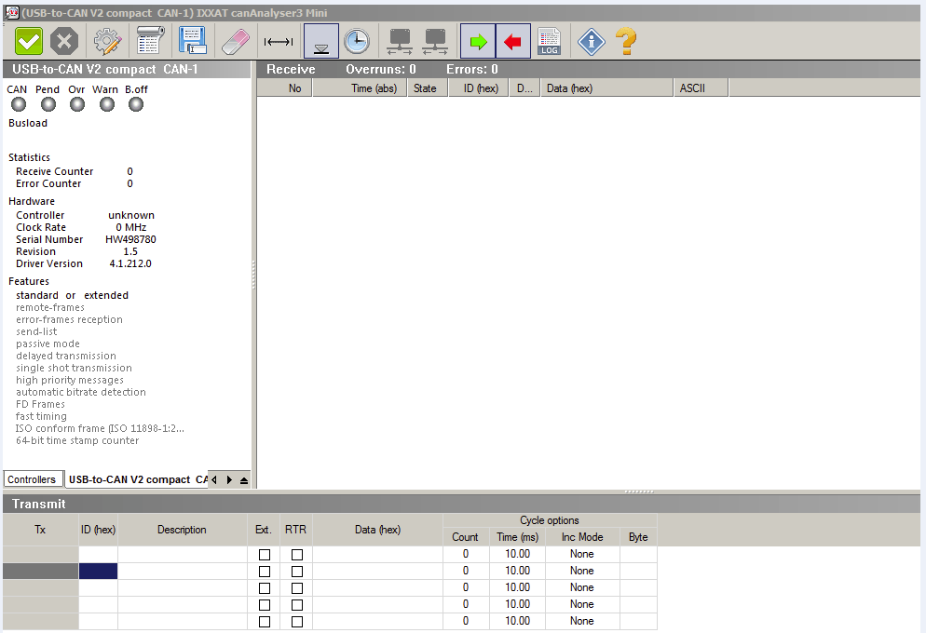

**3. All the messages will begin to scroll if the settings and the canb-bus with the control unit have been set correctly:**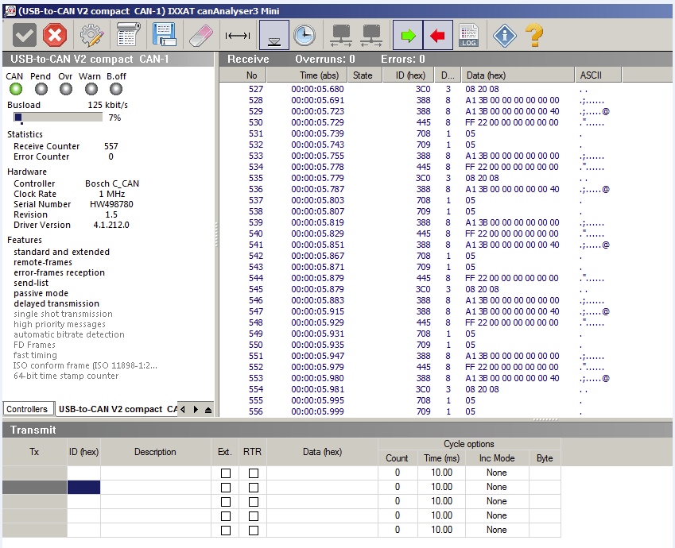

**4.ATTENTION: Set the DEBUG MESSAGE = 1 parameter on the inverter in special adjustment to allow you to throw out on the can-bus extra-info necessary for the analysis of the track by the Zapi technicians.**

**For INVERTER 2uC and NEW GEN🡪DEBUG CANMESSAGE = LEVEL 1 (SPECIAL ADJUST Menu)**

**5.Once ready, to start with the tests to be recorded, it is necessary to start the recording of the trace-can by clicking on the button cid:image015.png@01D82E20.55EA76D0 :**

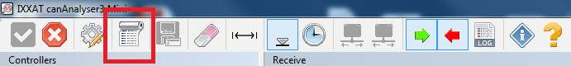

**6. A window will open asking where to go to save the track we are about to do on the PC:**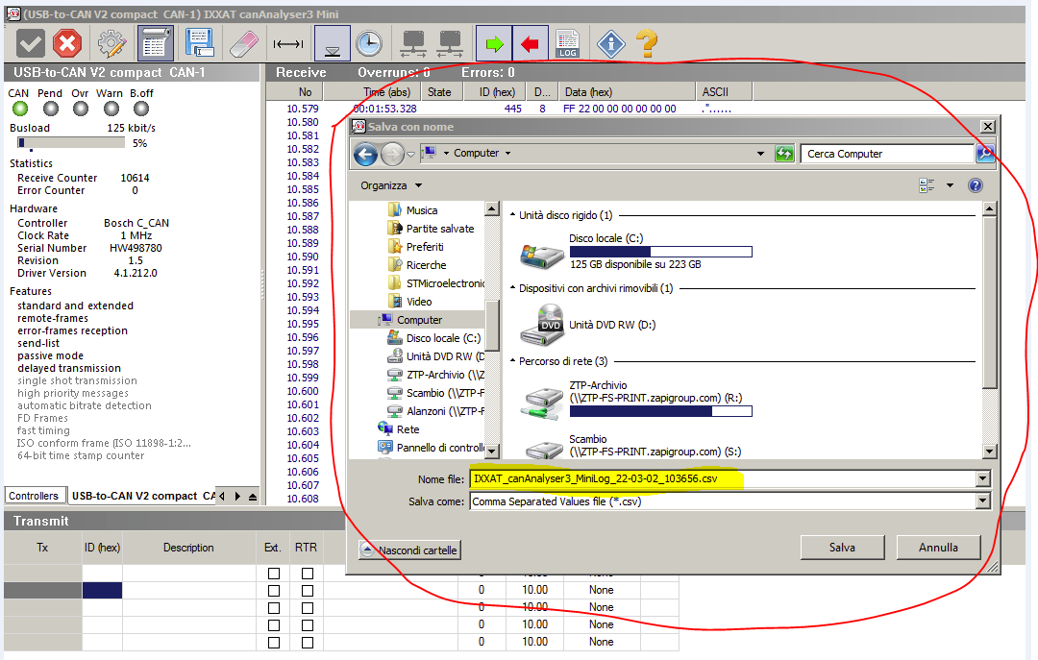

**7. So now the track begins to be recorded, to stop recording, you will need to click on the button again cid:image015.png@01D82E20.55EA76D0, then 2 files will be generated, one in * .csv format and one in * .tr0 format.**



**8. Send to the Zapi technicians the files of the can-traces (csv and tr0) and the parameter file of the parameters present on the Zapi control unit at the time of the recorded test.**

**9. End.**